Over the Hills Gang ATV Club Meeting Minutes
July 11th, 2026 – 9:30AM

Welcome | Pledge of Allegiance Called to Order by Steve Beneke

Introductions 16 people in attendance

Secretary Report Motion to approve by Janet Donner 2nd by Diane Scherf

Treasurer Report Motion to approve by Steve Beneke 2nd by Rod Wegner

Grant Manager Report - Separate handout

Safety
-No Updates Cindy Thompson stated that safety glasses or goggles should be worn while riding

Trail Updates

Events
-PNR
Over 300 people attended the 25th anniversary of our annual Pork N Ride event. Held at the Pickled Loon in Emily, MN the first of 7 Guided Group Rides started leaving at 8am. The Crooked Lake Fire Department was on hand to help riders safely cross Hwy 6 to access the trails. The Pickled Loon started the day with a burrito special to keep the riders fueled up, then followed up with a BBQ Buffet that was out of this world! Our thanks go out to the Servers, Bartenders, and Cooks at the Loon and to Larson for graciously hosting our event. All rides, except the "Thunder Lake Mud" ride, got back to the Loon in time for the drawing of our 50/50 raffle. But they knew what they were getting into by signing up for a ride with MUD right in the name! And we didn't disappoint them! Outing resident Brenda A. won the 50/50 raffle cash prize of $1250!! Congrats Brenda! We also ran a Membership drive, offering a free OTHG beanie hat to anyone who signed up for a membership. 8 new members signed up that day! All in all, it was a great way to celebrate 25 years of this great event!
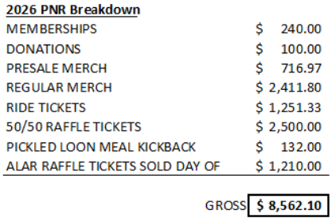

-Fifty Lakes Day – 208 Raffle tickets were sold ($1,040) & 6 new memberships. Lots of people stopped by.

-TODAY! - ATV Scavenger Hunt is happening immediately following the meeting.

-Saturday, July 18th - OTHG in the Emily Day parade. All are welcome. Lineup starts at 12:30 on the road just north of Sweets N Such. Decorate your machine and bring candy to toss.

-August 1st - Tacos on the Trail! Starts at Pickled Loon right after club meeting. Ride to White Oak campsite for "walking tacos". Group Ride?? Would need at least 1 Ride Leader. (need to update website to reflect this change from the Pizza Party Ride)
Website
-No Update

Facebook
-7386 Followers. Up 171 from June.
-Our content was viewed over 394,000 times in the month of June! That's the number of times our content was displayed on someone's device, even if they just scrolled past.
#3 post = Pork N Ride "Reel" posted during the event. 13,199 views
#2 post = Rock Crawl upgrade post on June 19th. 13,257 views
#1 post = Pork N Ride wrap up with pics and vids posted the night of the event. 23,852 views

Winter Riding
-No updates

Bylaws
-No Updates

Merchandise
-Available Merch budget balance - $4,041.02

Memberships
-42 Businesses & 268 Family (up 25 in a month)

Open Discussion Rock Crawl will be updated more towaeds fall as the club has been cleaning trails due to storms

Adjourn Motion made by Steve Beneke 2nd by Dave Thompson

