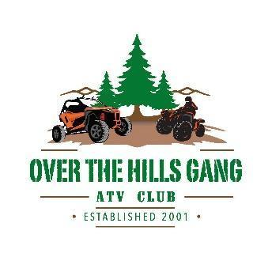 Over the Hills Gang ATV Club
2026 Ride & Event Schedule

February 7 Club Meeting 9:30am, Pickled Loon Saloon in Emily.
Membership mailer stuffing to follow.
March 7 Club Meeting 9:30am, Pickled Loon Saloon in Emily.
April 4 Club Meeting 9:30am, Pickled Loon Saloon in Emily.
April 10-11 Northern Off-Road Expo at the Northern Pacific Center in Brainerd. OTHG will be in the Northwoods ATV Trail Alliance booth.
May 2 Youth ATV Safety Training. Crooked Lake Town Hall in Outing.
To sign up call Cindy at 763-592-9330.
Morning session begins @ 8:30am.
Afternoon session begins @ 12:30pm.
May 3 Sunday Edition Club Meeting, Little Emily Lake Park @ 11am.
Adopt a Highway Clean-Up on Cass County Road 58 after the meeting.
Possible Trail Maintenance Ride to follow (weather permitting). Food will be provided for all who help with Trail Maintenance and Highway Clean Up.
June 6 Club Meeting 9:30am, Luscher’s Park in Outing.
June 13 25th Annual “PORK N RIDE” at the Pickled Loon Saloon in Emily, MN!
June 20 OTHG booth at Fifty Lakes Day. Merch and Raffle Tickets will be available.
July 11 Club Meeting 9:30am, Pickled Loon Saloon in Emily. ATV Scavenger Hunt after!
July 18 “Emily Day” Parade. ATVs & SXS are welcome to join the club in the parade!
August 1 Club Meeting 9:30am, Pickled Loon Saloon in Emily.
August 1 Pizza Party Ride!! Location TBD.
August 15 Lions Corn Feed at Pickled Loon in Emily. Volunteering event only.
August 29 Club Meeting 9:30am. Location TBD
September 12 “Ladies Only Ride”! Starting at Fifty Lakes Bar.
September 18-20 ATVMN Ride & Rally in Park Rapids, hosted by local ATV Clubs: Akeley Paul Bunyan Trail Riders, Forest Riders, Red River Riders, Timberland Dirt Devils, and Woods and Wheels. OTHG will lead a club ride.
September 26 Northwoods ATV Trail Alliance “Jamboree”. Leave from Village Inn parking lot, ride to Axtell ATV Park in McGregor.
October 3 “Autumn Log N Ride” with ATV & SXS Raffle at the Log Cabin in Emily.
October 10 Exploring MN ATV Trails ride with Cuyuna Iron Rang Riders. Cloquet Valley State Forest Trails in Melrude, MN.
October 31 End of Season Club Meeting & Elections 10am. Pickled Loon Saloon in Emily.
Informal HALOWEEN club ride to follow.
December 12 “Getting Loose on the Moose” Campfire Crawl winter ATV ride
on Moose River Trail.

*There are no club meetings in November, December, or January.
For additional details visit our website at www.overthehillsgang.org , our Facebook page, or send us your email to receive club newsletters.

